FORM BUILDER
Professional Production UI/UX Handoff
Field Workforce & Operations Management Platform
25 distinct approved UI screens / states
Consolidated from 28 supplied image attachments across two batches. Five exact duplicate attachments are represented once; two composite images are separated into their individual screens.
Source-of-truth rule
Supplied screenshots are visual authority. The UX flows in this document are behavioural authority. Do not substitute generic SaaS designs or silently merge conflicting variants.

1. Handoff Scope & Authority  Single-document implementation and visual QA reference | APPROVED UI/UX
Product context. The Form Builder is a reusable module inside the wider Field Workforce & Operations Management Platform. Purchase Requisition is the reference configuration shown in the supplied screens; it must not become hardcoded Form Builder behaviour.
Visual authority | Use the exact supplied screens for composition, hierarchy, density, spacing, navigation placement and properties-panel patterns.
Behavioural authority | Use the UX flows in Section 4 for creation, design, preview, publishing, runtime submission, approvals, versioning and import.
Variant handling | Where two non-identical variants were supplied for the same feature, both are retained and labelled. Do not combine them without an explicit product decision.
Scope discipline | Visible controls do not automatically expand implementation scope. Advanced connectors, delegation/escalation, offline/API access or templates still require approved product/backend scope.
Attachment reconciliation
Image attachments received | 28
Exact duplicate attachments | 5
Unique image files | 23
Composite files containing two screens | 2
Distinct UI screens / states | 25

2. Visual & Interaction System  Observed patterns across the supplied screens | APPROVED UI/UX
Shell & navigation  Emerald/dark-green top shell on most screens, white left navigation, pale-green selected states and compact secondary builder navigation. | Workspace  White/light-gray operational surfaces, thin cool-gray/blue borders, minimal shadow and dense enterprise spacing. | Typography & status  Dark navy headings, compact labels and semantic green/blue/amber/red status treatments.
Builder pattern  Top-level builder tabs plus either right-side property panels or large modal configurators. Work canvas remains dominant. | Tables & lists  Dense rows, compact search/filter controls, explicit sorting/filtering and visible row actions. | Runtime pattern  Header/main information first, configured tabs below, primary task buttons visible, supporting summary/status panels alongside.
Visible consistency differences — retain, do not hide:
• Top builder navigation differs: some screens show Data Sources as a top tab; others keep it in the left navigation.
• Workflow exists in a simpler stage-settings variant and a more advanced conditions/delegation/escalation variant.
• Rules, Preview and List View each have multiple non-identical visual variants.
• Most screens use WorkFlow Pro green shell; Create New Form uses a Contoso Operations/light-shell variant.
• Create New Form includes Templates in navigation, but no template-selection screen was supplied.

3. Approved Screen Inventory  All distinct screens / states from both supplied batches | APPROVED UI/UX
ID | Screen / State | Category | Source
S01 | End-user Purchase Requisition / New Request | Runtime · Requester | Modern Purchase Requisition Dashboard(2).png
S02 | Documents / Attachments Tab Configuration | Builder · Tab configuration | WorkFlow Pro Attachment Builder(2).png
S03 | Data Sources / Lookups Configuration | Builder · Data | Purchase Requisition Data Sources Dashboard(2).png
S04 | Submission List / Purchase Requisitions | Operations · Submissions | WorkFlow Pro Purchase Requisitions Dashboard(2).png
S05 | Notes Tab Configuration | Builder · Tab configuration | WorkFlow Pro Notes Tab Builder (1)(1).png
S06 | Form Preview — Interactive / Role-based Variant | Builder · Preview | Purchase Requisition Form Preview(3).png
S07 | Approval Workflow Configuration — Stage Settings Variant | Builder · Workflow | WorkFlow Pro Approval Workflow Dashboard(3).png
S08 | Form Preview — Device / Test Form Variant | Builder · Preview | Purchase Requisition Form Preview(1) (1)(1).png
S09 | Rules / Conditions Builder — IF / THEN Variant | Builder · Rules | Form Rules Builder Dashboard (1)(1).png
S10 | Form Settings | Builder · Settings | Purchase Requisition Form Settings Dashboard(2).png
S11 | Add Tab / Tab Type Selection | Builder · Design | WorkFlow Pro Tab Configuration Preview(2).png
S12 | List View Configuration — Column Setup Variant | Builder · List View | WorkFlow Pro List View Configuration(2).png
S13 | Form Versions / Version History | Builder · Versioning | WorkFlow Pro Version History Dashboard(2).png
S14 | Rules / Conditions Builder — Rule Type Variant | Builder · Rules | Purchase Requisition Rule Builder(2).png
S15 | Header Configuration | Builder · Design | Modern Form Header Configuration Dashboard(2).png
S16 | Details / Grid Tab Configuration | Builder · Tab configuration | Purchase Requisition Tab Builder(2).png
S17 | Create New Form | Builder · Creation | Contoso Form Builder Setup(2).png
S18 | List View Configuration — Preview / Formatting Variant | Builder · List View | Purchase Requisition List View Configuration(2).png
S19 | Import / Export Form — Import Configuration | System · Portability | S19-import-export-initial.png
S20 | Publish Form — Validation Errors / Warnings | System · Publishing | S20-publish-validation-errors.png
S21 | Approver Review / Pending Approval | Operations · Approval | WorkFlow Pro Purchase Approval Dashboard(2).png
S22 | Submission Record View — In Review | Operations · Record | WorkFlow Pro Purchase Requisition Review(2).png
S23 | Approval Workflow Configuration — Full Workflow Variant | Builder · Workflow | WorkFlow Pro Approval Workflow Dashboard(1)(2).png
S24 | Import / Export Form — Validation Success | System · Portability | S24-import-validation-success.png
S25 | Publish Form — All Checks Passed / Ready to Publish | System · Publishing | S25-publish-ready.png

4. End-to-End UX Flows  Screen IDs map directly to the screen catalog | APPROVED UI/UX
F01 · Create → Configure → Preview → Publish | S17 → S11 → S15 → S16 and/or S05 / S02 → S03 where lookup data is needed → S10 → S09 or S14 → S07 or S23 → S12 or S18 → S06 or S08 → S20 when issues exist → fix → S25 → publish.

F02 · Requester Submission | S01 → complete main information and configured tabs → Save as Draft or Submit Request → S04 submission tracking → S22 record view.

F03 · Approval Decision | Approvals / pending work → S21 → review record, items, documents, notes and progress → Approve / Reject / Return → S22 and S04 reflect updated status/progress.

F04 · Publish Error Recovery | S20 → Go to Workflow / Go to Fields / Configure → correct the relevant builder configuration → re-run validation → S25 → Publish Form.

F05 · Versioning / Edit Published Form | S13 → inspect version → Duplicate as New Version / create draft → normal builder flow → Preview → Publish validation → publish new version; historical versions remain historical.

F06 · Import Existing Definition | S19 → upload JSON and choose new/update/validate-only path → validate → S24 → import to draft → review in builder → Preview → Publish.

F07 · Data Source to Lookup | S03 → create/select source → configure mapping/connectivity → use it from lookup-capable fields in builder → verify in Preview before Publish. No dedicated standalone Field Properties screen was supplied in these two batches.

5.01 S01 · End-user Purchase Requisition / New Request  Runtime · Requester | APPROVED UI/UX
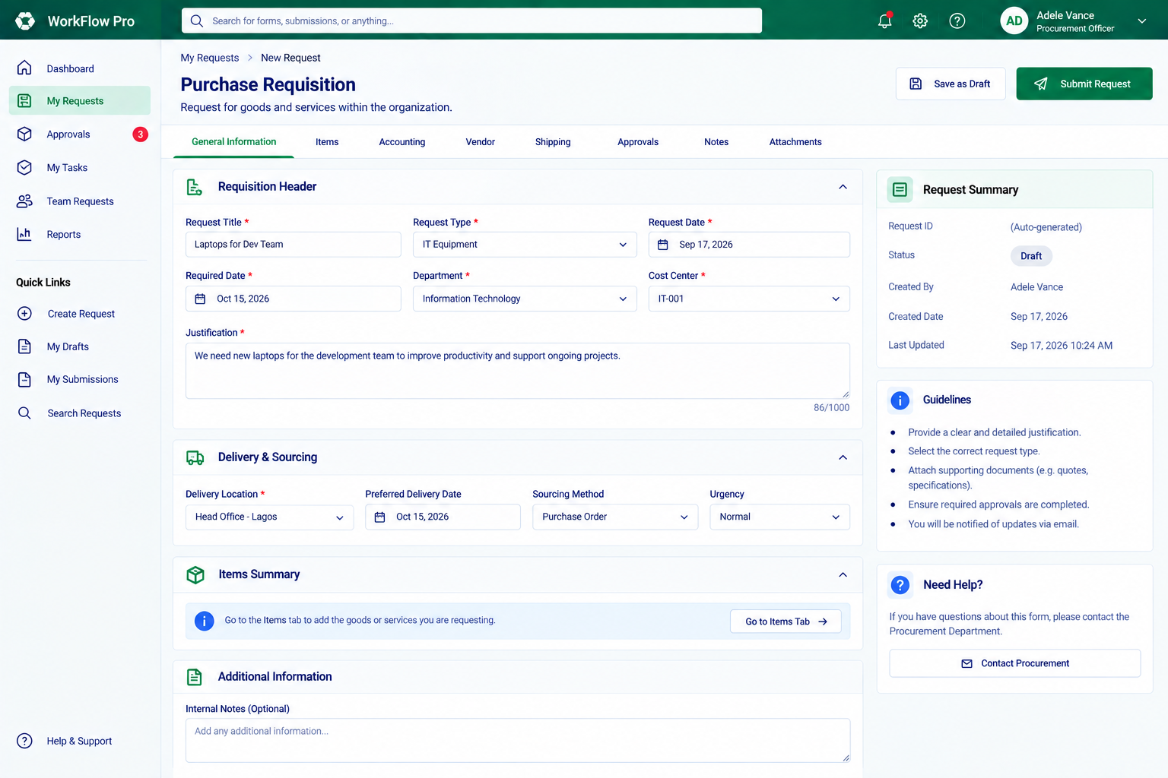
Purpose | Entry | Primary actions | Exit / transition | Implementation note
Capture a new purchase requisition in the published end-user experience. | My Requests → New Request. | Complete General Information and other configured tabs; Save as Draft; Submit Request. | Draft remains editable, or a submitted request moves into submission tracking and the approval lifecycle. | Shows the runtime pattern: header/main information first, tabbed work areas, request summary, guidance and contextual help.
Source: Modern Purchase Requisition Dashboard(2).png

5.02 S02 · Documents / Attachments Tab Configuration  Builder · Tab configuration | APPROVED UI/UX
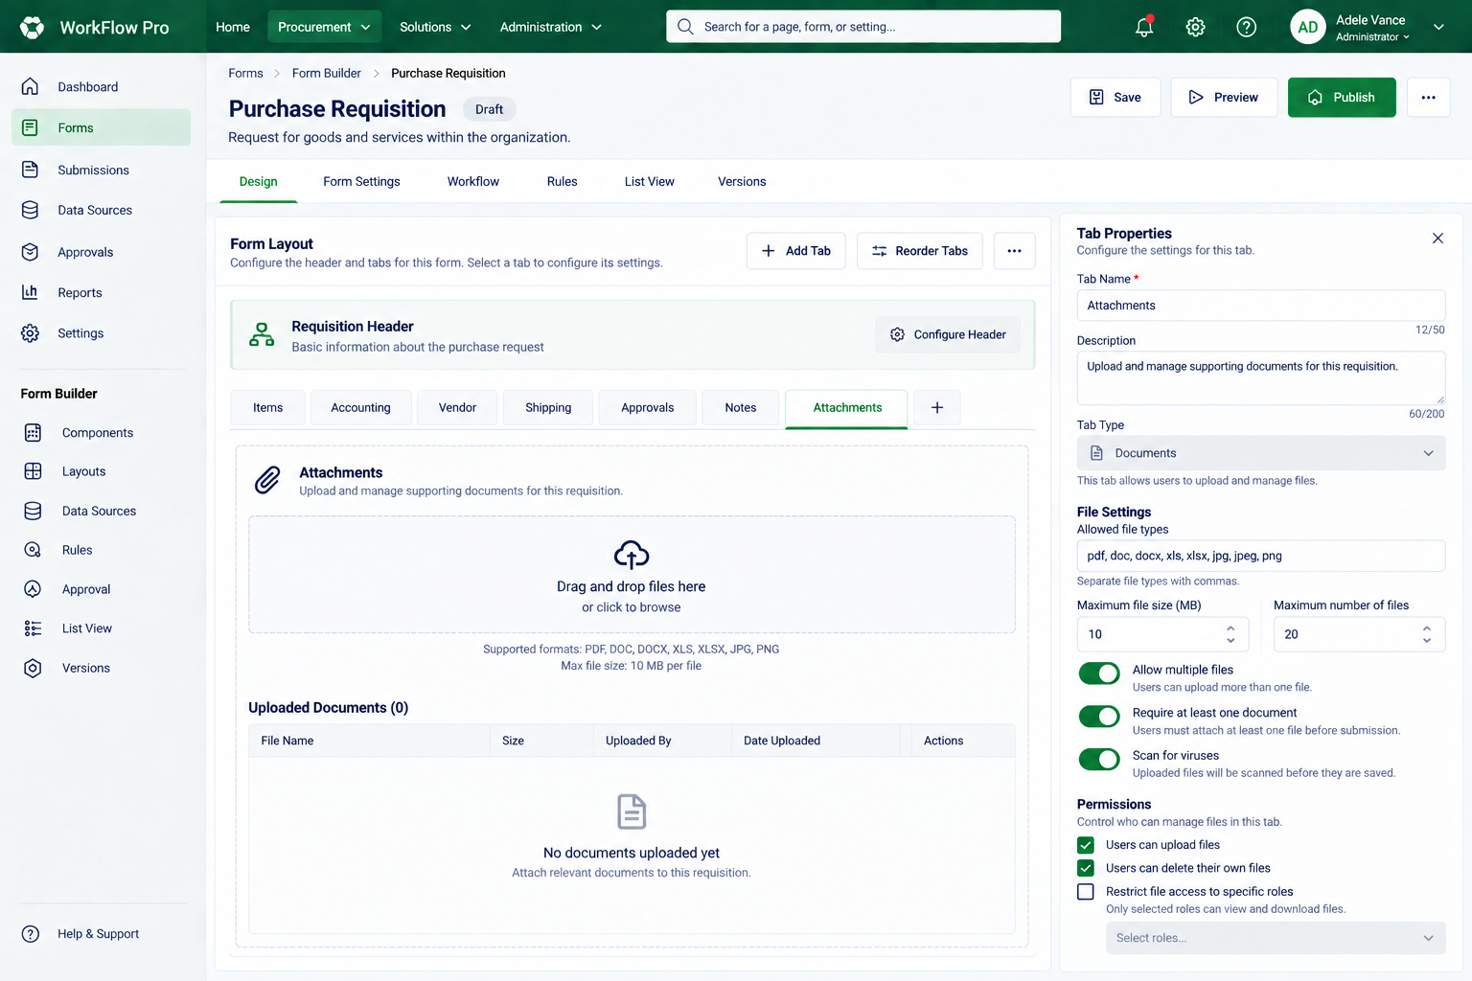
Purpose | Entry | Primary actions | Exit / transition | Implementation note
Configure a Documents-type tab inside the form design. | Form Builder → Design → select the Attachments tab. | Configure tab name/description/type, allowed file types, max file size/count, multiple-file and required-file behaviour, scan toggle and permissions. | The Documents tab configuration remains part of the current form draft. | This is configuration UI, not the end-user attachment screen.
Source: WorkFlow Pro Attachment Builder(2).png

5.03 S03 · Data Sources / Lookups Configuration  Builder · Data | APPROVED UI/UX
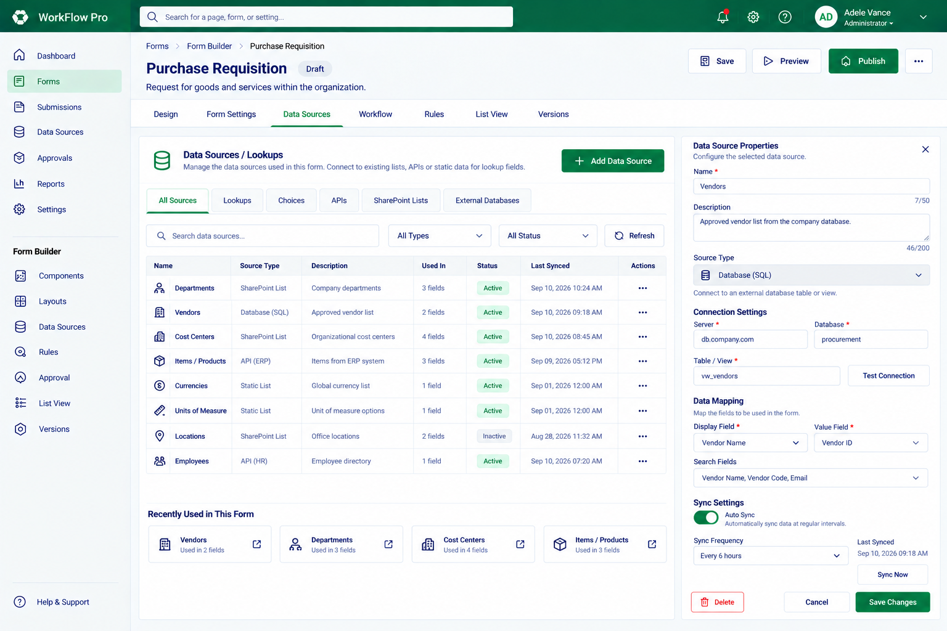
Purpose | Entry | Primary actions | Exit / transition | Implementation note
Manage reusable data sources used by lookup fields. | Data Sources / Lookups management. | Search sources, add a data source, edit source properties, configure connection details, test connection, map display/value fields, sync. | Configured sources become available to lookup-enabled form fields. | The supplied UI visibly includes static lists, APIs, SharePoint lists and external databases. Implementation scope for each connector must follow the backend/product plan.
Source: Purchase Requisition Data Sources Dashboard(2).png

5.04 S04 · Submission List / Purchase Requisitions  Operations · Submissions | APPROVED UI/UX
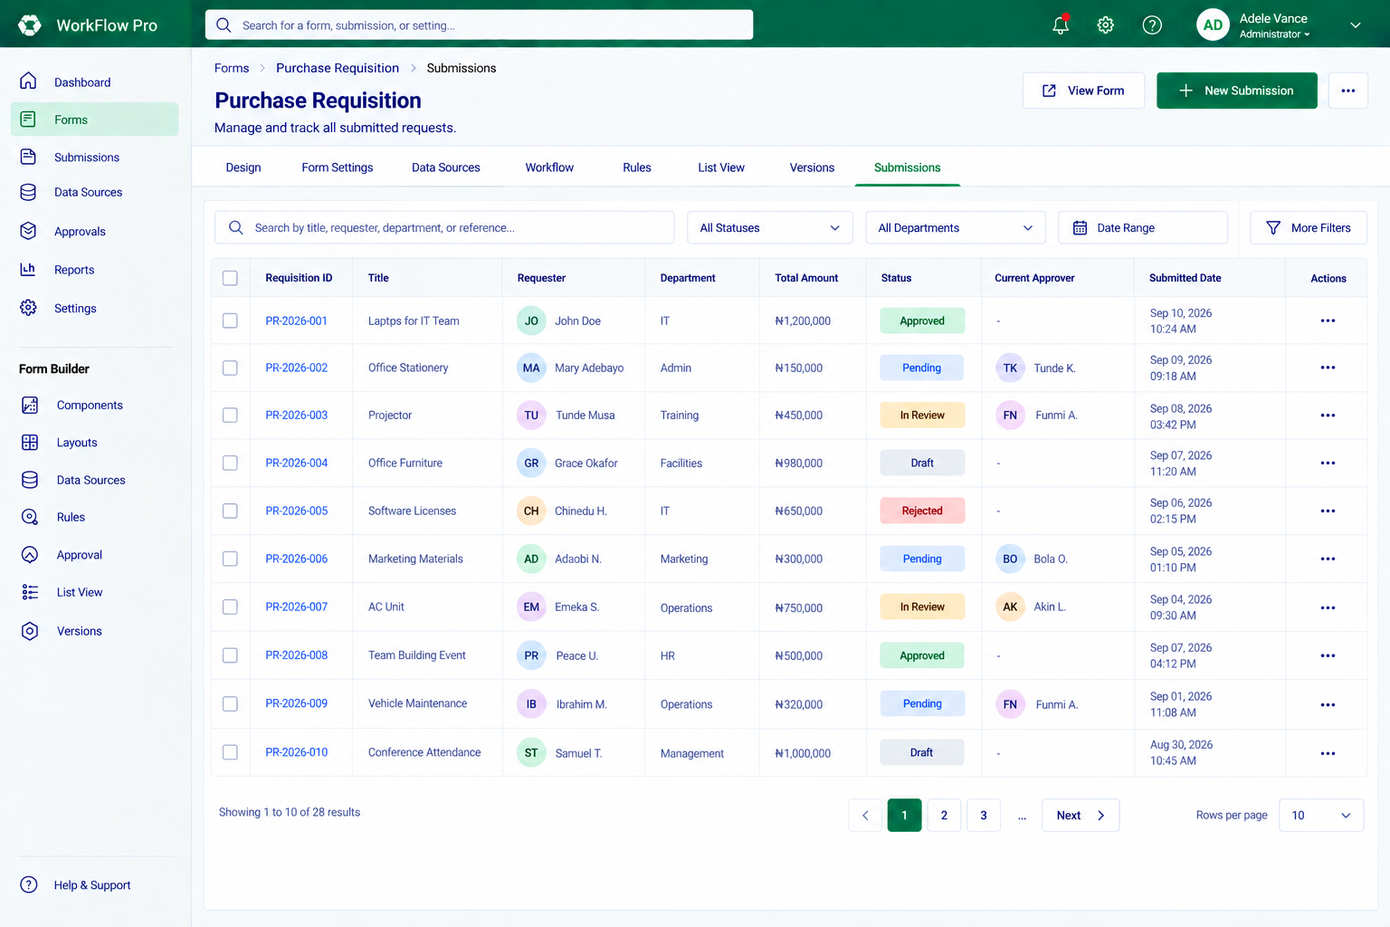
Purpose | Entry | Primary actions | Exit / transition | Implementation note
Manage and track submitted requests in a dense operational list. | Forms → Purchase Requisition → Submissions. | Search, filter by status/department/date, apply more filters, open a row, create a new submission, view the form. | Open Submission Record, start New Submission, or remain in the filtered list. | Configured list columns and system status/approver fields are combined in the operational table.
Source: WorkFlow Pro Purchase Requisitions Dashboard(2).png

5.05 S05 · Notes Tab Configuration  Builder · Tab configuration | APPROVED UI/UX
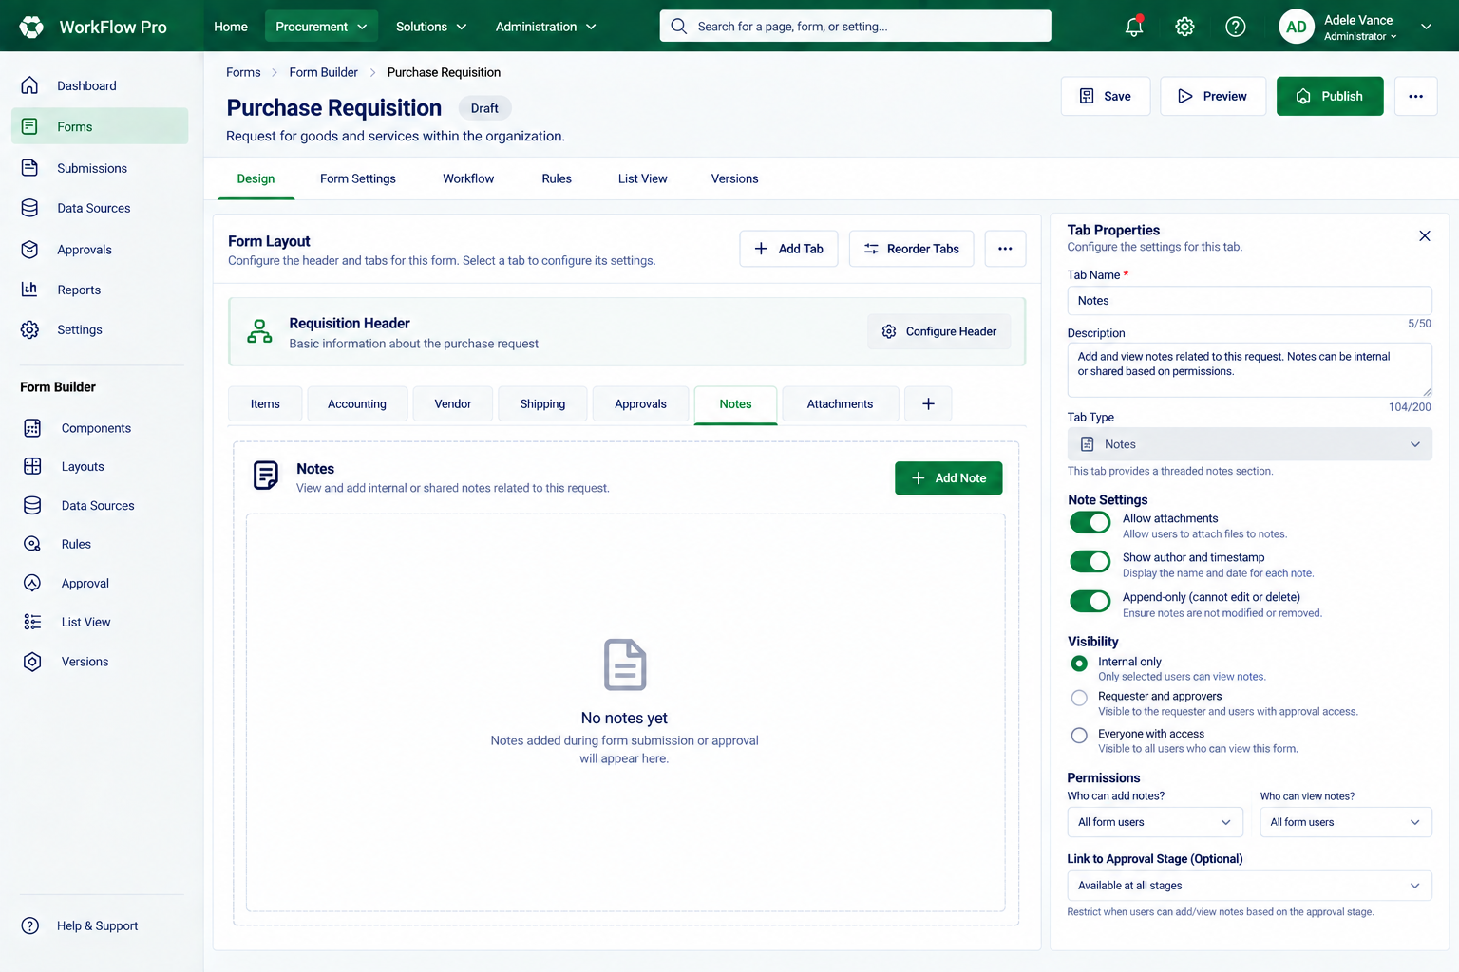
Purpose | Entry | Primary actions | Exit / transition | Implementation note
Configure the threaded Notes-type tab. | Form Builder → Design → select Notes. | Set tab metadata, attachments, author/timestamp visibility, append-only behaviour, visibility audience, permissions and optional approval-stage linkage. | The Notes configuration remains part of the current form draft. | The screen explicitly presents notes as a history/thread rather than a single overwriteable text field.
Source: WorkFlow Pro Notes Tab Builder (1)(1).png

5.06 S06 · Form Preview — Interactive / Role-based Variant  Builder · Preview | APPROVED UI/UX
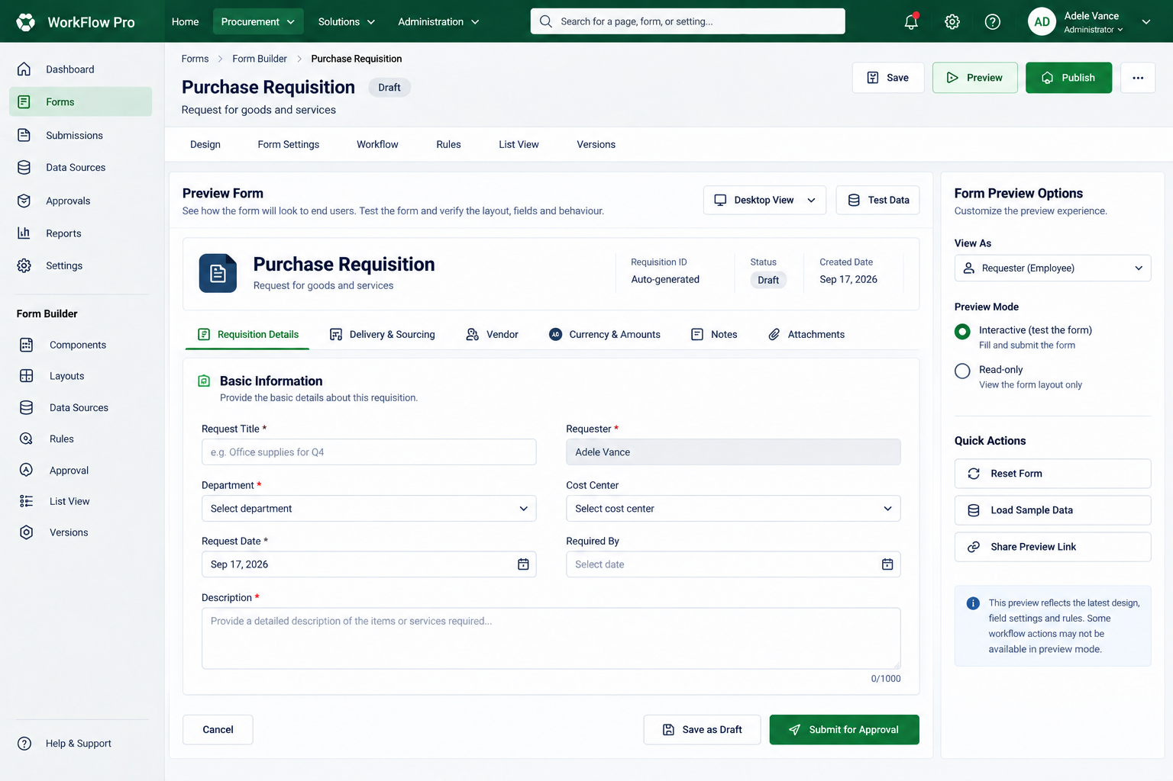
Purpose | Entry | Primary actions | Exit / transition | Implementation note
Test the draft form from an end-user role before publication. | Form Builder → Preview. | Select viewport/view-as role, choose interactive or read-only preview, reset/load sample data, navigate tabs and test form behaviour. | Return to builder configuration; preview does not represent the published form. | The source screen notes that some workflow actions may not be available in preview mode.
Source: Purchase Requisition Form Preview(3).png

5.07 S07 · Approval Workflow Configuration — Stage Settings Variant  Builder · Workflow | APPROVED UI/UX
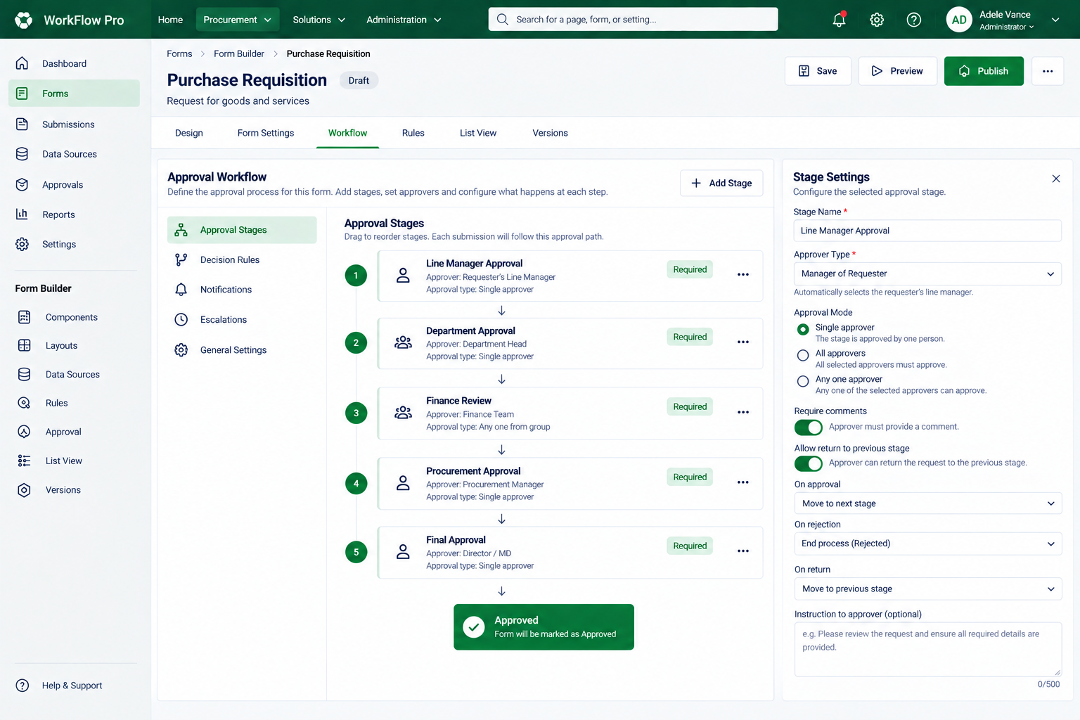
Purpose | Entry | Primary actions | Exit / transition | Implementation note
Configure ordered approval stages and the selected stage settings. | Form Builder → Workflow. | Add/reorder stages, set approver type, approval mode, comment requirements, return behaviour and outcomes on approve/reject/return. | Workflow configuration remains attached to the form draft and is validated before publish. | Sidebar also exposes Decision Rules, Notifications, Escalations and General Settings as visible design areas.
Source: WorkFlow Pro Approval Workflow Dashboard(3).png

5.08 S08 · Form Preview — Device / Test Form Variant  Builder · Preview | APPROVED UI/UX
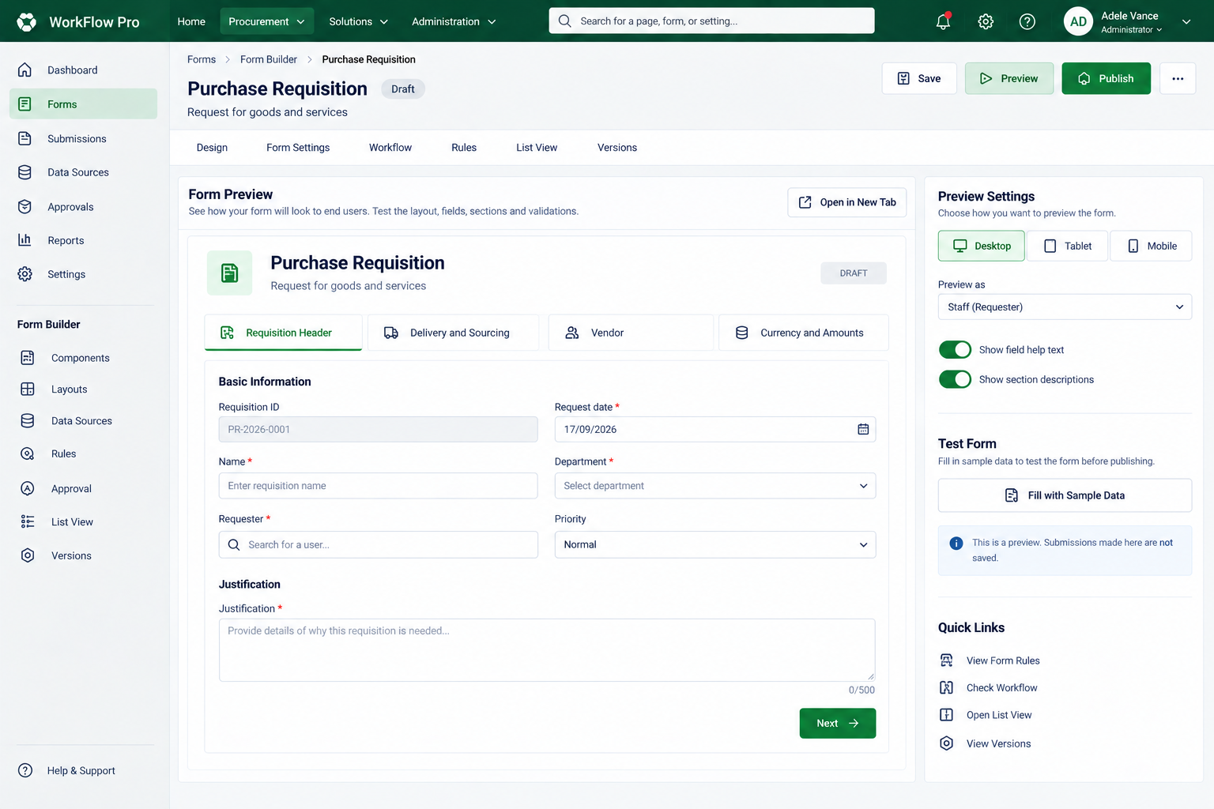
Purpose | Entry | Primary actions | Exit / transition | Implementation note
Preview the draft form across desktop/tablet/mobile presentation modes. | Form Builder → Preview. | Switch device preview, preview as a role, toggle help/section descriptions, fill sample data and inspect configured tabs. | Return to builder after visual/behavioural verification. | The screen explicitly states that submissions made in this preview are not saved.
Source: Purchase Requisition Form Preview(1) (1)(1).png

5.09 S09 · Rules / Conditions Builder — IF / THEN Variant  Builder · Rules | APPROVED UI/UX
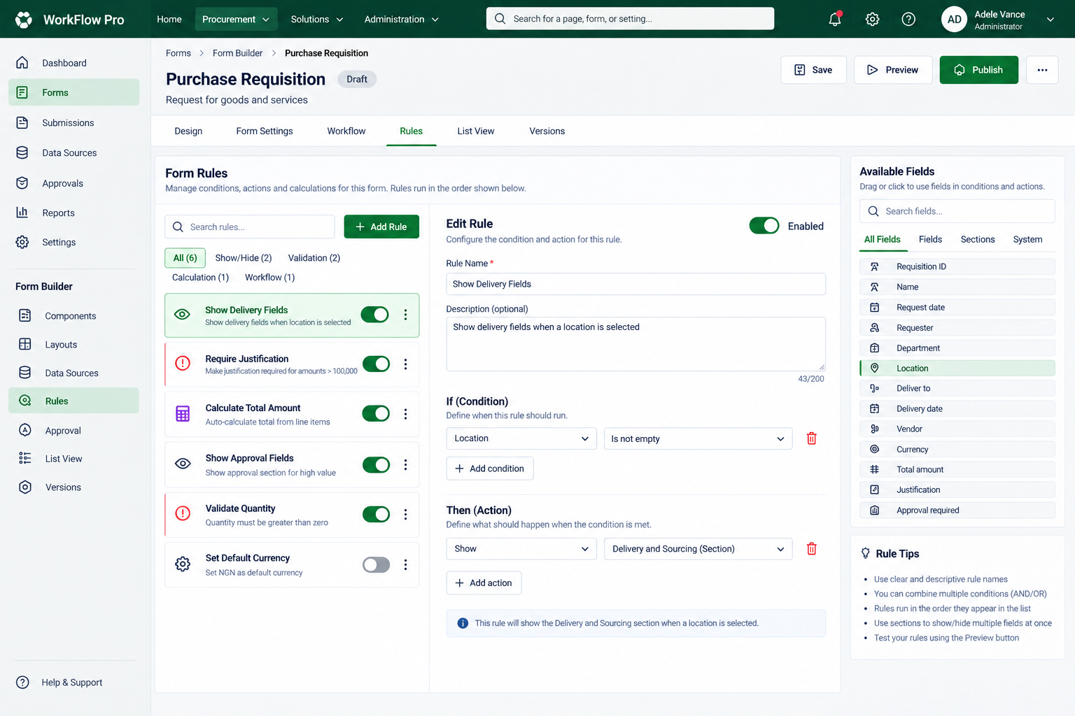
Purpose | Entry | Primary actions | Exit / transition | Implementation note
Create and manage declarative form rules. | Form Builder → Rules. | Search/add rules, enable/disable a rule, define IF condition(s), THEN action(s), and select fields/sections/system values. | Rule remains in draft configuration and is tested through Preview / Publish validation. | Rule group tabs shown include Show/Hide, Validation, Calculation and Workflow.
Source: Form Rules Builder Dashboard (1)(1).png

5.10 S10 · Form Settings  Builder · Settings | APPROVED UI/UX
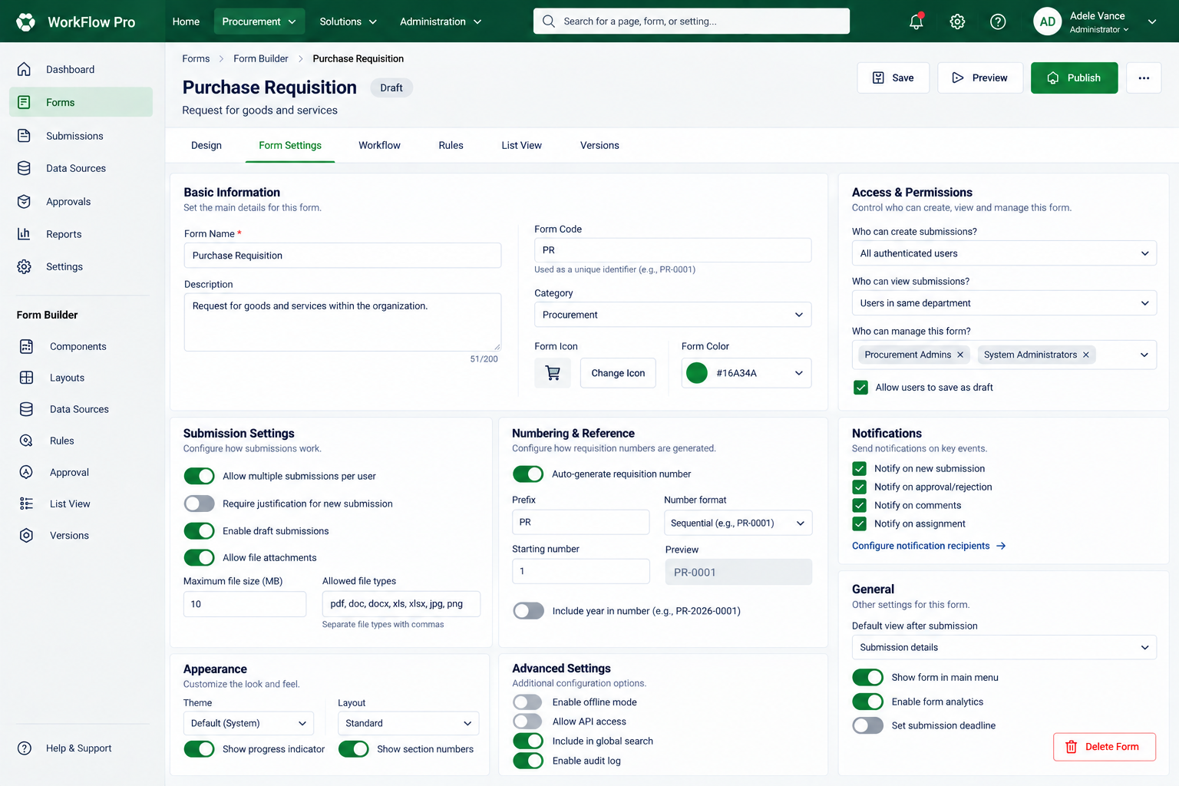
Purpose | Entry | Primary actions | Exit / transition | Implementation note
Configure form-wide metadata, permissions and submission behaviour. | Form Builder → Form Settings. | Edit basic information, access/permissions, submission settings, numbering/reference, notifications, general settings, appearance and advanced settings. | Settings persist in the form draft and are checked before publication. | Offline mode, API access and analytics controls are visible in the source design; their implementation scope must be confirmed separately.
Source: Purchase Requisition Form Settings Dashboard(2).png

5.11 S11 · Add Tab / Tab Type Selection  Builder · Design | APPROVED UI/UX
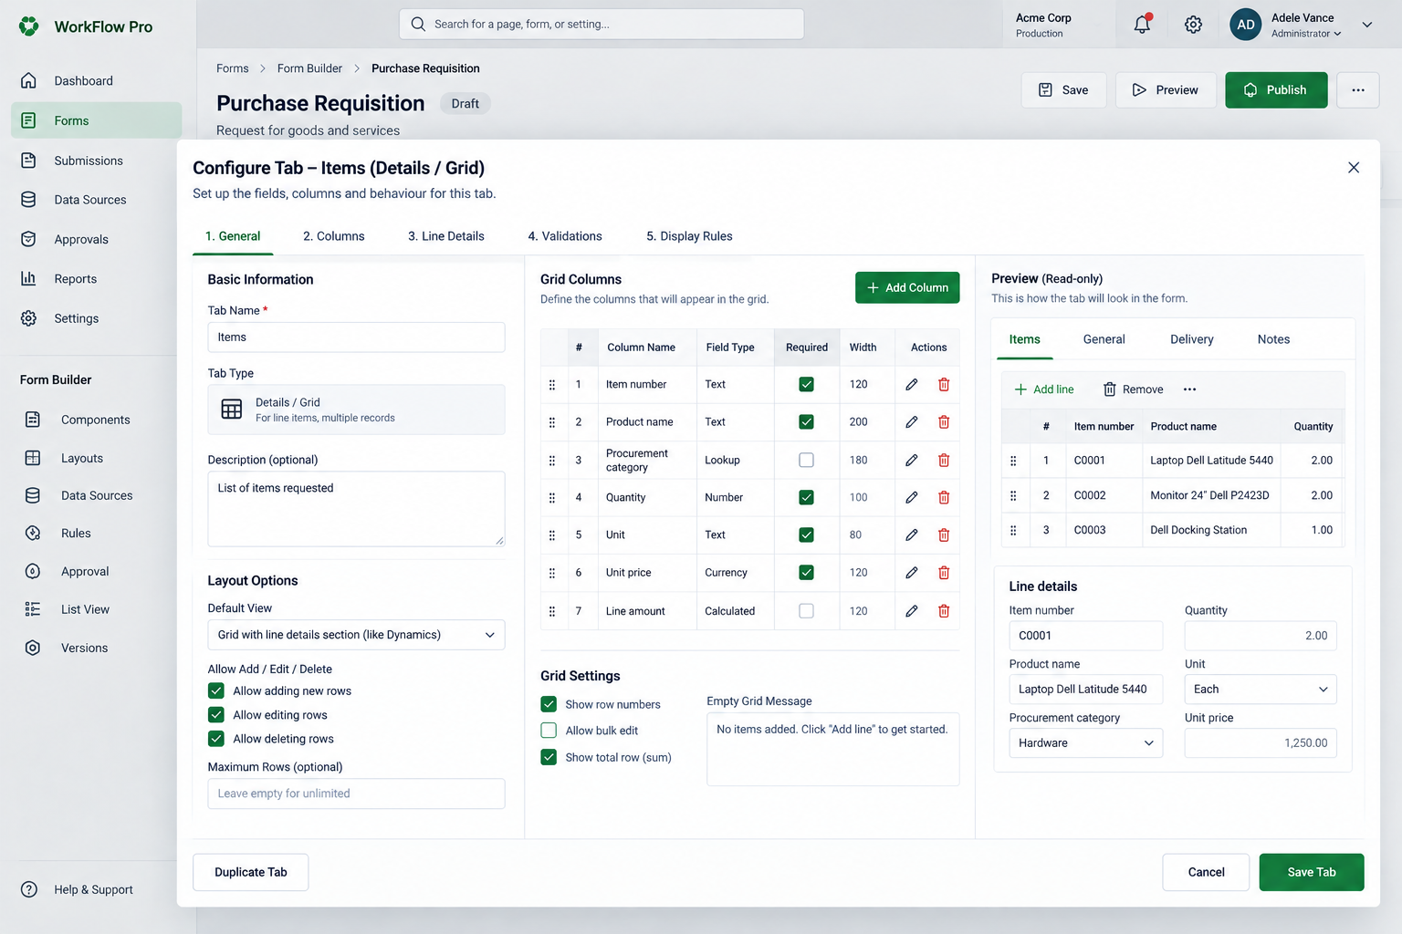
Purpose | Entry | Primary actions | Exit / transition | Implementation note
Add a new configurable tab beneath the form header. | Form Builder → Design → Add Tab. | Name the tab; choose Details/Grid, Form/Fields, Notes or Documents; set icon, position, initial layout, visibility and help text. | Add Tab creates the tab and returns the user to its type-specific configuration. | This is the clearest source screen defining the four tab types.
Source: WorkFlow Pro Tab Configuration Preview(2).png

5.12 S12 · List View Configuration — Column Setup Variant  Builder · List View | APPROVED UI/UX
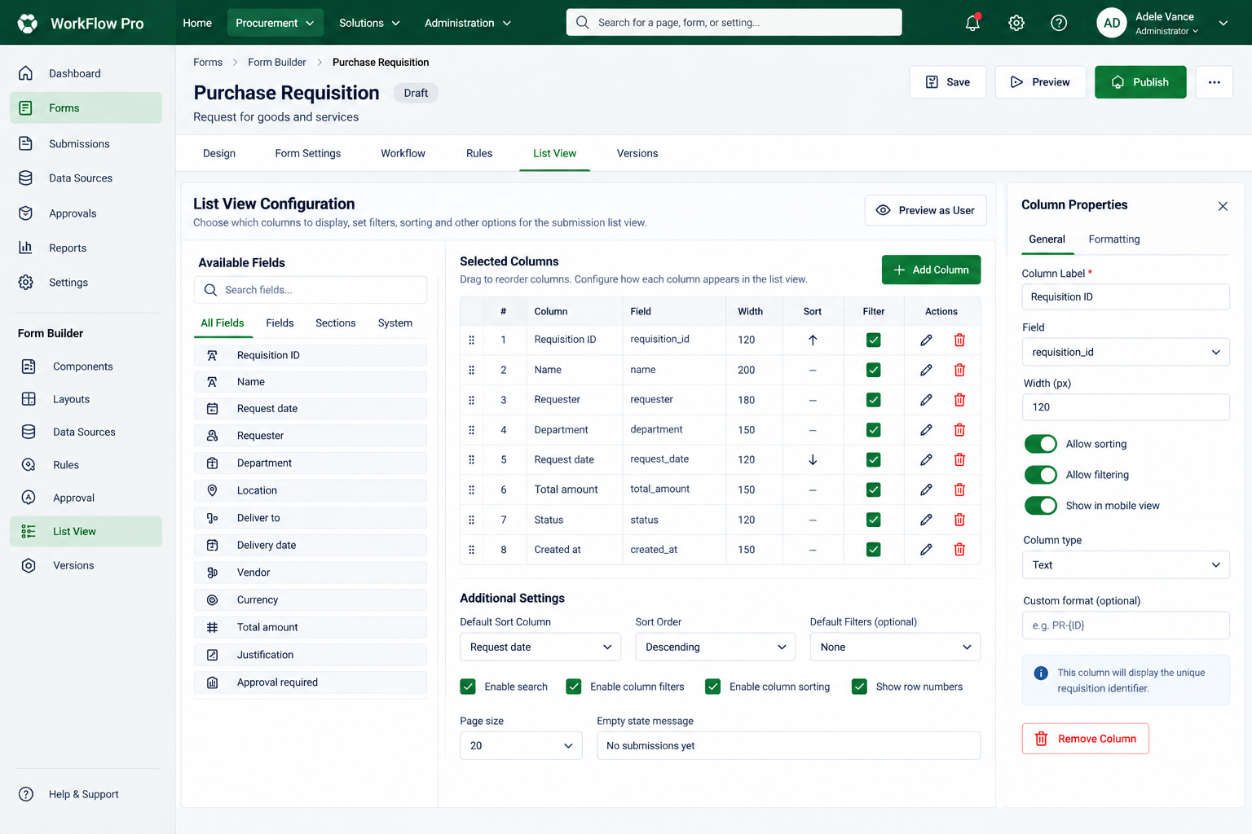
Purpose | Entry | Primary actions | Exit / transition | Implementation note
Define which fields appear in the submissions list and how they behave. | Form Builder → List View. | Add/reorder selected columns, edit field/label/width, allow sorting/filtering/mobile display, configure default sorting, search, page size and empty state. | Configuration drives the operational Submission List. | This variant emphasizes selected columns and a dedicated Column Properties panel.
Source: WorkFlow Pro List View Configuration(2).png

5.13 S13 · Form Versions / Version History  Builder · Versioning | APPROVED UI/UX
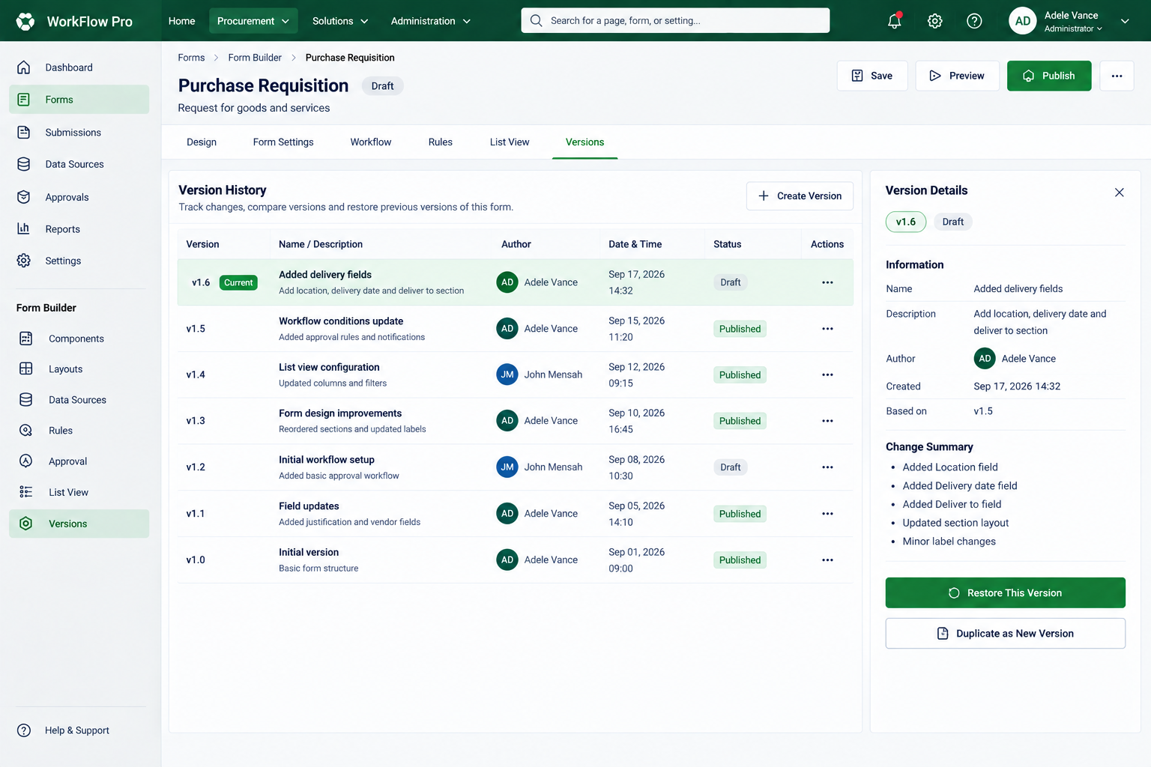
Purpose | Entry | Primary actions | Exit / transition | Implementation note
Track form versions and create a safe path for future edits. | Form Builder → Versions. | Inspect version metadata/change summary, restore/select a historical version, duplicate as a new version, create a version. | Editing should continue through a new draft/version rather than mutating historical published data. | The UI shows Draft and Published history together with current-version detail.
Source: WorkFlow Pro Version History Dashboard(2).png

5.14 S14 · Rules / Conditions Builder — Rule Type Variant  Builder · Rules | APPROVED UI/UX
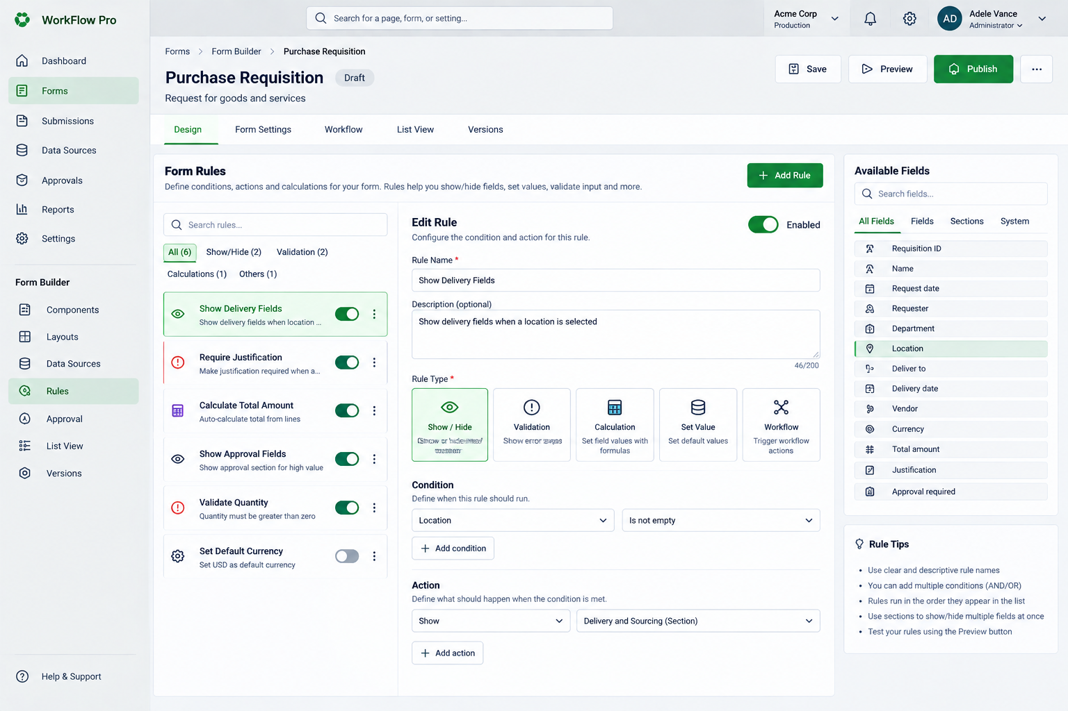
Purpose | Entry | Primary actions | Exit / transition | Implementation note
Configure rules with explicit rule-type selection. | Form Builder → Rules. | Choose Show/Hide, Validation, Calculation, Set Value or Workflow rule type; define condition and action; enable/disable rule. | Rule becomes part of the draft configuration for Preview and Publish validation. | This is a distinct visual variant from S09 and should not be silently merged during implementation.
Source: Purchase Requisition Rule Builder(2).png

5.15 S15 · Header Configuration  Builder · Design | APPROVED UI/UX
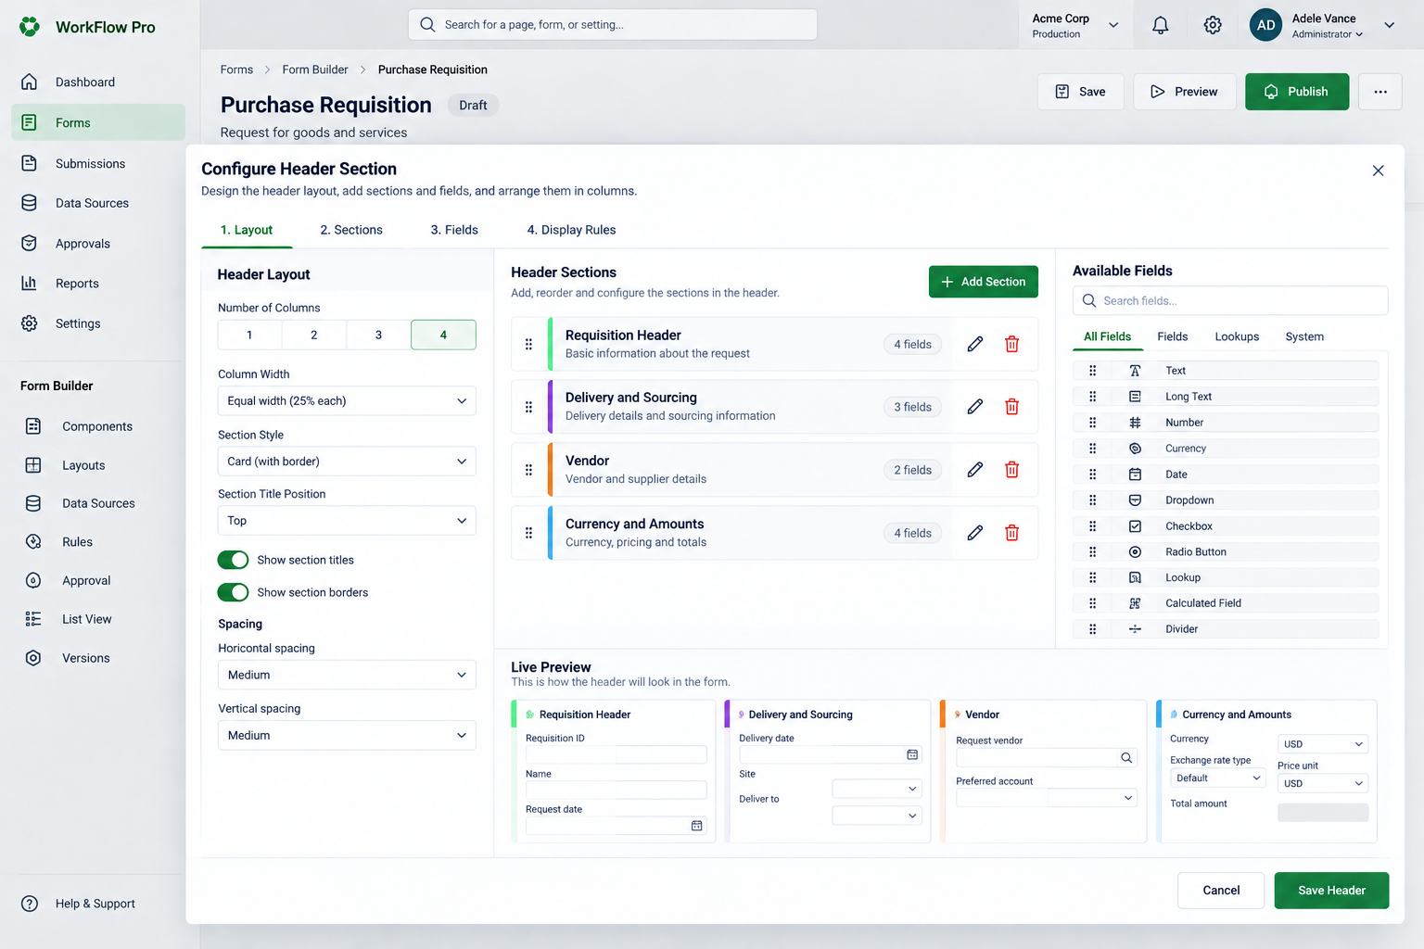
Purpose | Entry | Primary actions | Exit / transition | Implementation note
Design the main/header area that appears above form tabs. | Form Builder → Design → Configure Header. | Configure Layout, Sections, Fields and Display Rules; choose 1–4 columns, section style/titles/spacing, add/reorder sections and fields; inspect Live Preview. | Save Header returns the user to the form design workspace. | Supports controlled layout rather than arbitrary pixel positioning.
Source: Modern Form Header Configuration Dashboard(2).png

5.16 S16 · Details / Grid Tab Configuration  Builder · Tab configuration | APPROVED UI/UX
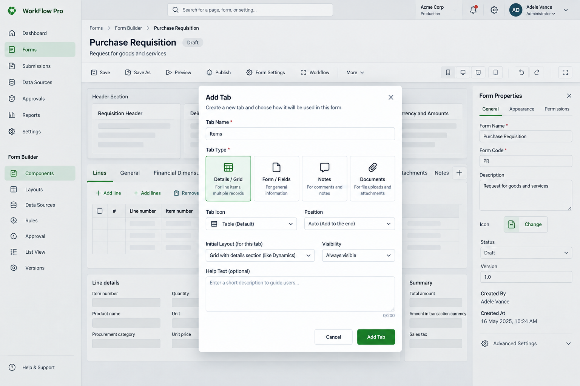
Purpose | Entry | Primary actions | Exit / transition | Implementation note
Configure a repeating row/grid tab and its line-detail experience. | Form Builder → Design → select a Details/Grid tab. | Configure General, Columns, Line Details, Validations and Display Rules; add/reorder columns; set row behaviour and grid options; inspect read-only preview. | Save Tab returns to the builder with updated grid configuration. | The source explicitly supports add/edit/delete rows and an optional line-details section.
Source: Purchase Requisition Tab Builder(2).png

5.17 S17 · Create New Form  Builder · Creation | APPROVED UI/UX
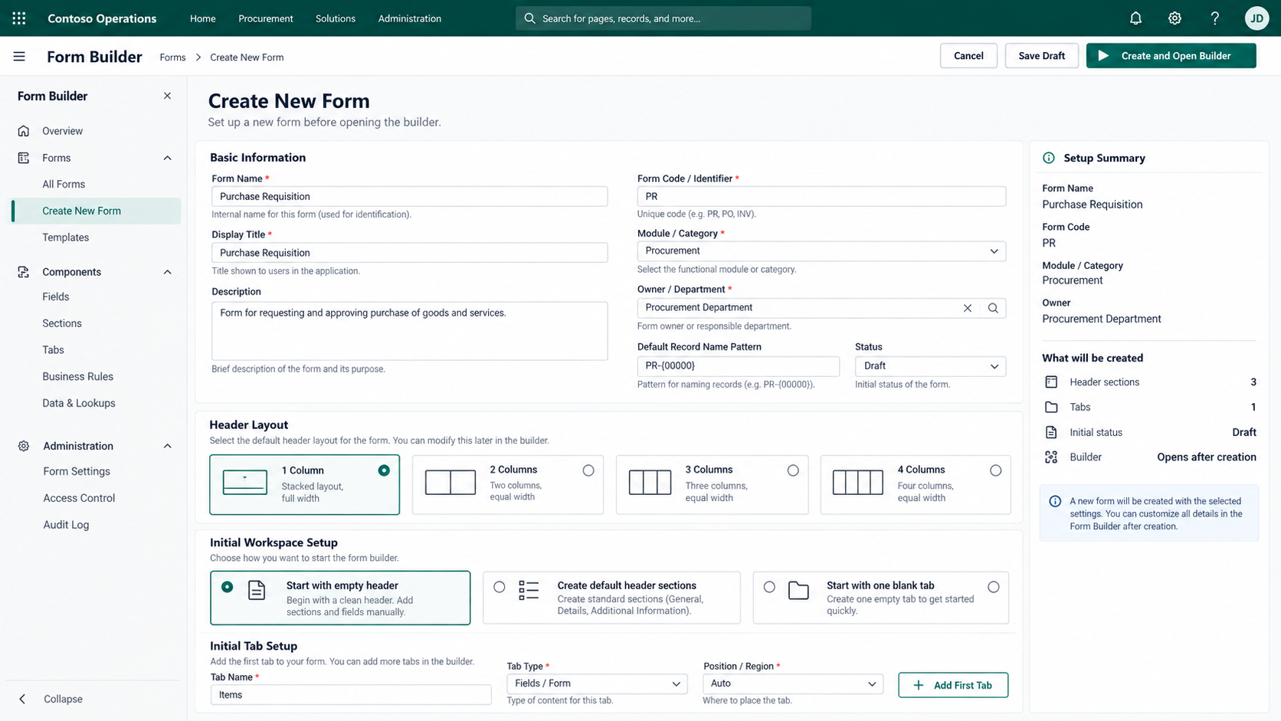
Purpose | Entry | Primary actions | Exit / transition | Implementation note
Create a new form definition and initial workspace structure. | Form Builder → Forms → Create New Form. | Enter form metadata, choose header layout, choose initial workspace setup, configure the first tab, Save Draft or Create and Open Builder. | Creates a draft form and opens the builder when requested. | A Templates navigation item is visible, but no template-selection flow was supplied in these batches.
Source: Contoso Form Builder Setup(2).png

5.18 S18 · List View Configuration — Preview / Formatting Variant  Builder · List View | APPROVED UI/UX
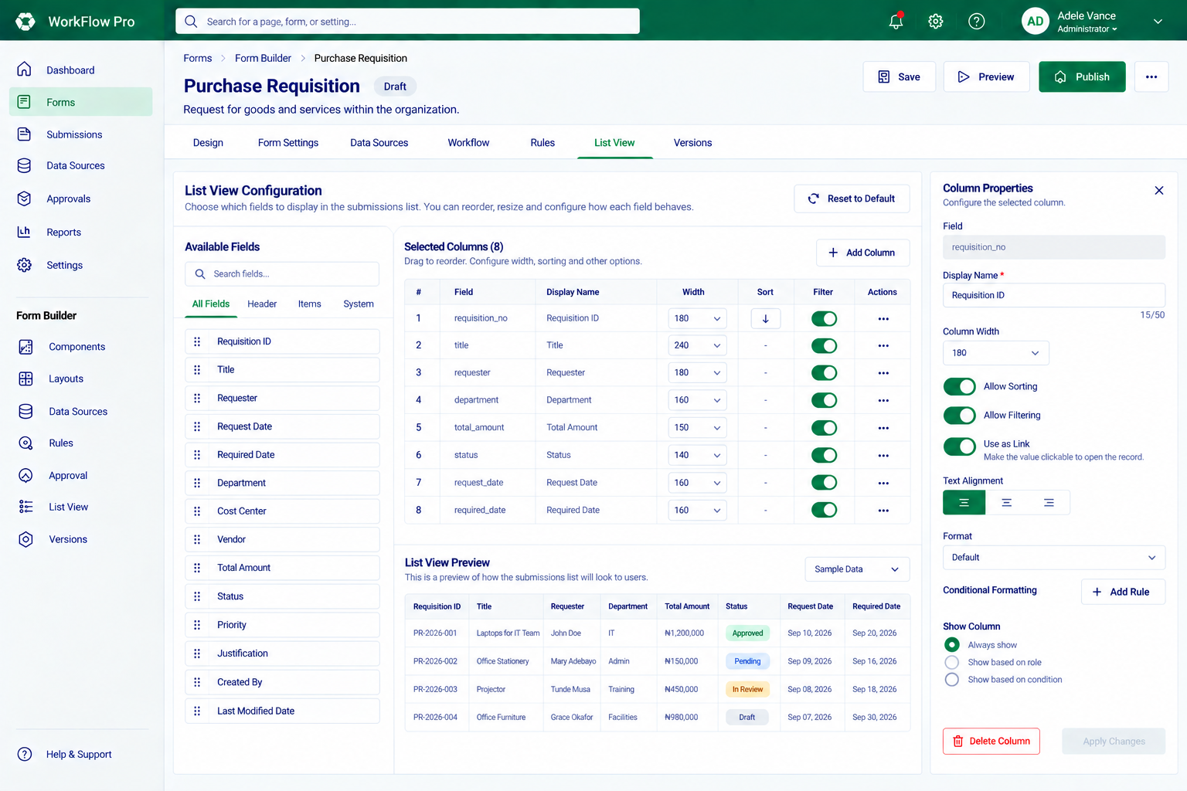
Purpose | Entry | Primary actions | Exit / transition | Implementation note
Configure list columns while previewing the resulting submission table. | Form Builder → List View. | Select fields, reorder columns, edit display name/width/sort/filter/link behaviour/alignment/format, add conditional formatting, control column visibility. | List View Preview reflects the draft configuration used by the Submission List. | This is a distinct visual variant from S12 and includes more formatting/visibility controls.
Source: Purchase Requisition List View Configuration(2).png

5.19 S19 · Import / Export Form — Import Configuration  System · Portability | APPROVED UI/UX
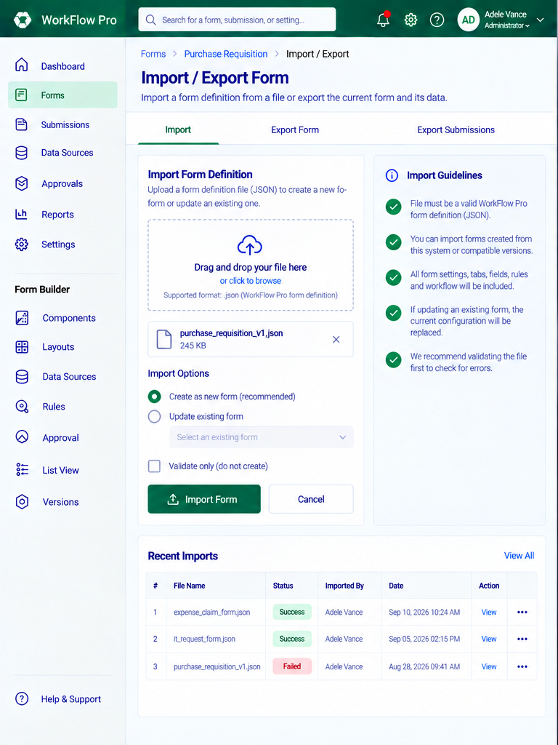
Purpose | Entry | Primary actions | Exit / transition | Implementation note
Upload a form definition and choose how the import should be handled. | Forms → Purchase Requisition → Import / Export. | Upload JSON, choose Create as new form / Update existing form / Validate only, run Import Form, inspect Recent Imports. | Validation/import result or return to the form. | Export Form and Export Submissions tabs are visible, but detailed export-tab screens were not supplied.
Source: S19-import-export-initial.png

5.20 S20 · Publish Form — Validation Errors / Warnings  System · Publishing | APPROVED UI/UX
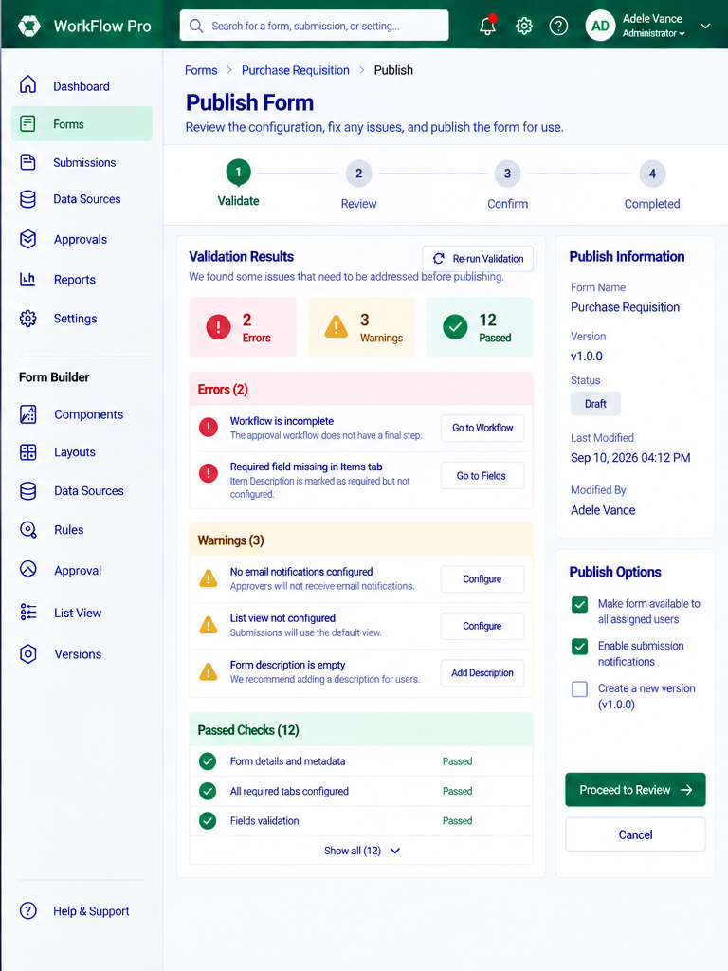
Purpose | Entry | Primary actions | Exit / transition | Implementation note
Block publication until configuration errors are resolved. | Form Builder → Publish. | Review errors, warnings and passed checks; use Go to Workflow / Go to Fields / Configure links; re-run validation; review publish options. | Return to affected configuration areas or proceed toward Review only after blocking errors are resolved. | The source uses a four-step publish journey: Validate → Review → Confirm → Completed.
Source: S20-publish-validation-errors.png

5.21 S21 · Approver Review / Pending Approval  Operations · Approval | APPROVED UI/UX
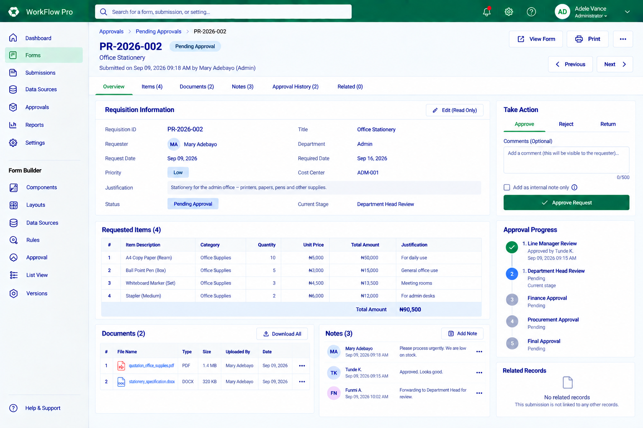
Purpose | Entry | Primary actions | Exit / transition | Implementation note
Give the current approver a focused decision workspace. | Approvals → Pending Approvals → selected request. | Review requisition information/items/documents/notes/history; choose Approve, Reject or Return; add comments/internal note; move Previous/Next. | Decision updates Approval Progress and the request lifecycle. | This is the dedicated approval-action experience, distinct from the general record view.
Source: WorkFlow Pro Purchase Approval Dashboard(2).png

5.22 S22 · Submission Record View — In Review  Operations · Record | APPROVED UI/UX
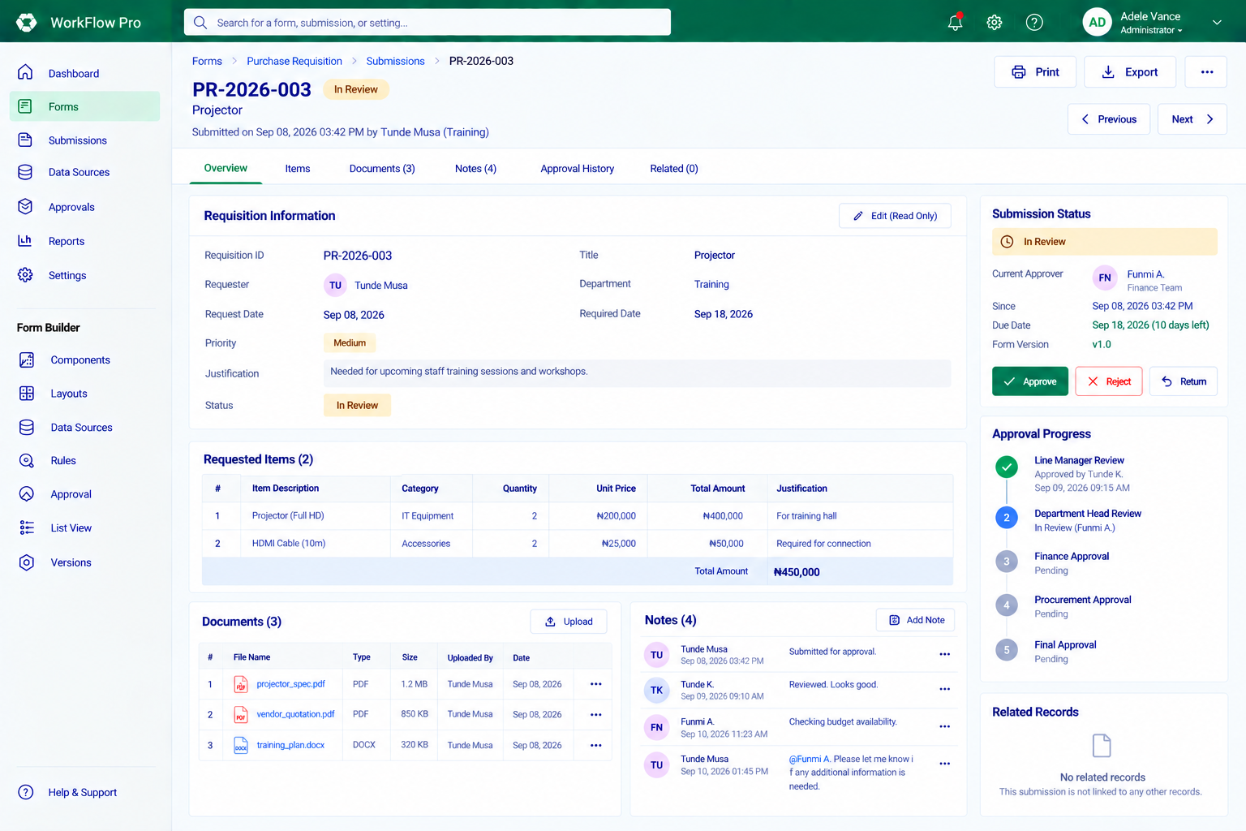
Purpose | Entry | Primary actions | Exit / transition | Implementation note
Display the complete submitted record and its current workflow state. | Forms → Purchase Requisition → Submissions → selected record. | Review overview/items/documents/notes/approval history/related records; print/export; inspect status, current approver and approval progress. | Return to submission list, navigate Previous/Next, or take an available approval action when authorized. | The supplied screen is an In Review state and includes approval controls in the status panel.
Source: WorkFlow Pro Purchase Requisition Review(2).png

5.23 S23 · Approval Workflow Configuration — Full Workflow Variant  Builder · Workflow | APPROVED UI/UX
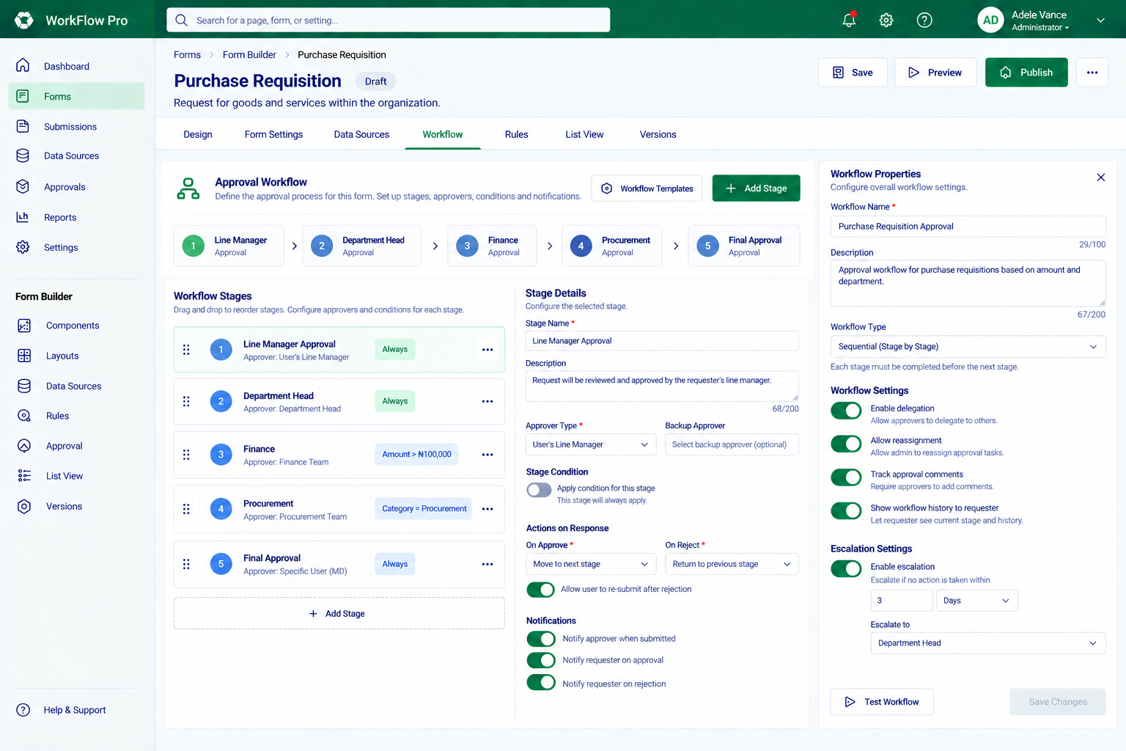
Purpose | Entry | Primary actions | Exit / transition | Implementation note
Configure stages, selected-stage behaviour and workflow-wide properties in one workspace. | Form Builder → Workflow. | Add/reorder stages, set approver/backup/condition, configure approve/reject responses and notifications; configure delegation, reassignment, history and escalation settings. | Test workflow or keep configuration in the current form draft. | This is a more advanced workflow variant than S07; advanced capabilities visible here should follow confirmed product scope.
Source: WorkFlow Pro Approval Workflow Dashboard(1)(2).png

5.24 S24 · Import / Export Form — Validation Success  System · Portability | APPROVED UI/UX
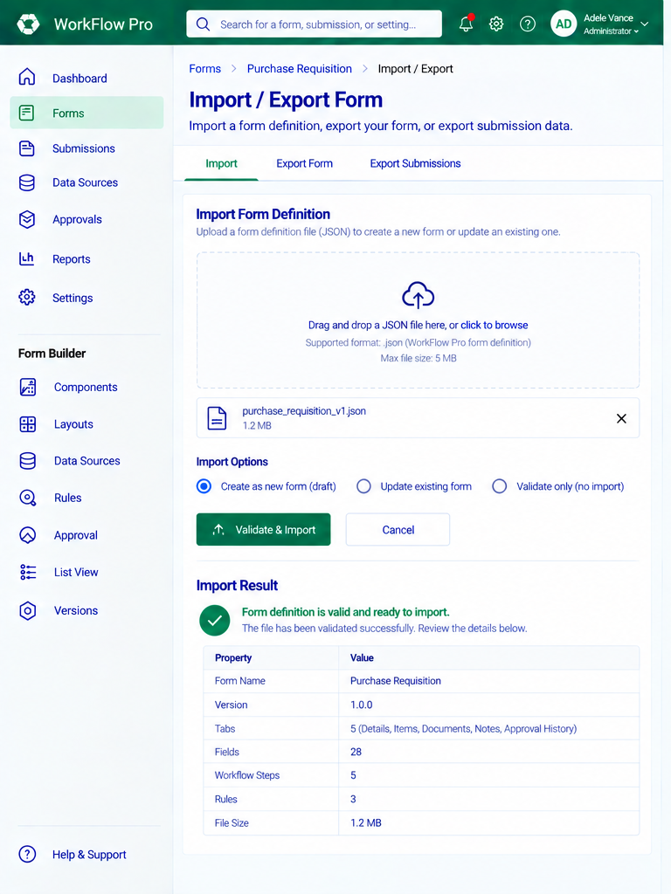
Purpose | Entry | Primary actions | Exit / transition | Implementation note
Confirm that an uploaded form definition is valid before import. | Import Form Definition after selecting a JSON file. | Review successful validation result and imported definition summary; proceed with Validate & Import or cancel. | Create/update the form draft according to the selected import option. | The source shows form/version/tab/field/workflow/rule metadata after validation.
Source: S24-import-validation-success.png

5.25 S25 · Publish Form — All Checks Passed / Ready to Publish  System · Publishing | APPROVED UI/UX
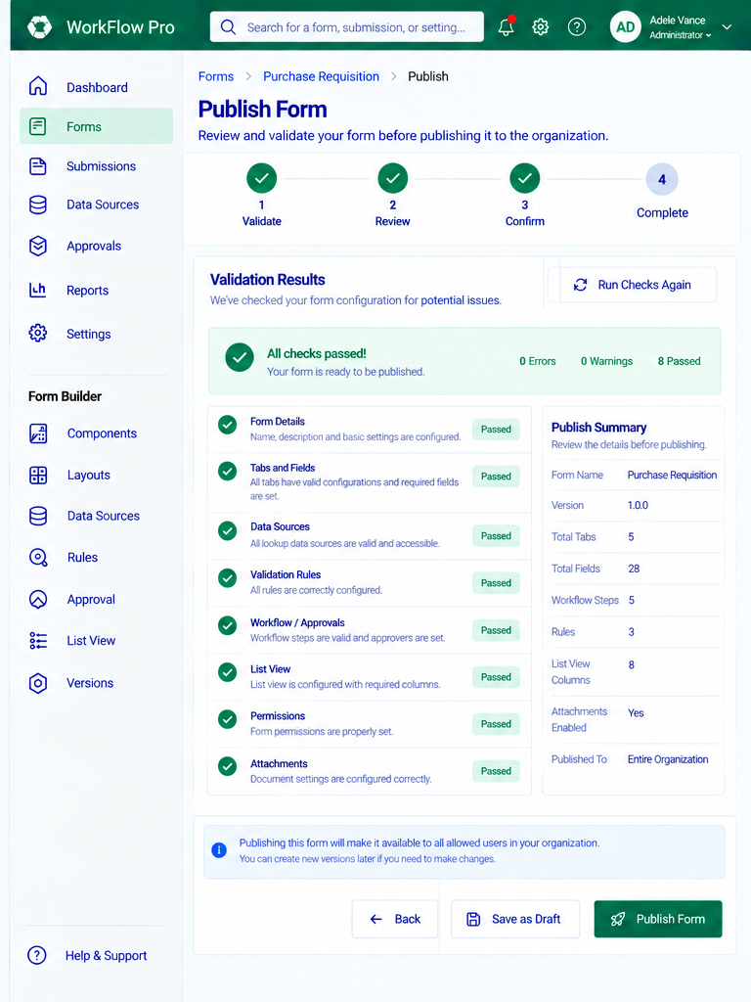
Purpose | Entry | Primary actions | Exit / transition | Implementation note
Provide the final publish confirmation after validation succeeds. | Publish flow after all blocking checks pass. | Review passed checks and Publish Summary; go Back, Save as Draft or Publish Form. | Publish the validated form for its configured audience, or return without publishing. | This is the ready-to-publish state corresponding to the error state in S20.
Source: S25-publish-ready.png

6. Production Implementation Requirements  Required even where a dedicated mockup state is not supplied | APPROVED UI/UX
Visual fidelity | Match the selected source variant. Preserve composition, density, panel structure, spacing rhythm, tabs, tables and the green/navy design language.
Reusable architecture | Purchase Requisition is sample configuration. Builder, renderer, tabs, grids, notes, documents, rules, workflow and list views must remain reusable/configuration driven.
State coverage | Implement loading, empty, error, disabled, permission-denied, validation, unsaved-change and retry states where relevant.
Accessibility | Keyboard-operable dialogs/panels/tables/actions, visible focus states, semantic labels, understandable errors and practical touch targets.
Responsive behaviour | Builder is desktop-oriented; runtime, record and approval views should adapt to smaller widths without turning the MVP into a mobile authoring product.
Lifecycle integrity | Restore/edit actions must not mutate historical published versions. Continue edits through a new draft/version and republish.
Backend authority | Do not invent APIs or make the client authoritative for permissions, approval lifecycle, version state or persistence.
Variant control | Rules, Workflow, Preview and List View have multiple supplied variants. The implementation task must identify the target variant; otherwise stop and ask.
Definition of done for a UI slice
☐ Target screen and exact variant are explicitly identified.
☐ Layout is visually compared against the supplied reference.
☐ Primary flow, back/cancel path and lifecycle transition work.
☐ Loading/empty/error/validation/permission states are handled where relevant.
☐ Reusable Form Builder primitives do not contain Purchase Requisition-specific core logic.
☐ Lint, typecheck and relevant tests pass.
☐ A visual QA screenshot is reviewed before moving to the next screen.

7. Source Reconciliation  Duplicate attachments accounted for without duplicating the same screen | APPROVED UI/UX
Exact duplicate attachments received:
Duplicate filename | Representation
WorkFlow Pro Notes Tab Builder(2).png | same image as WorkFlow Pro Notes Tab Builder (1)(1).png → S05
Purchase Requisition Form Preview(1)(2).png | same image as Purchase Requisition Form Preview(1) (1)(1).png → S08
Form Rules Builder Dashboard(2).png | same image as Form Rules Builder Dashboard (1)(1).png → S09
Modern Purchase Requisition Dashboard(3).png | same image as Modern Purchase Requisition Dashboard(2).png → S01
WorkFlow Pro Attachment Builder(3).png | same image as WorkFlow Pro Attachment Builder(2).png → S02
Composite handling: WorkFlow Pro Import & Publish Dashboards(2).png was split into S19/S20. WorkFlow Pro Form Publishing Dashboard(2).png was split into S24/S25. No screen was regenerated.

